Data Warehouse Conceptual Design

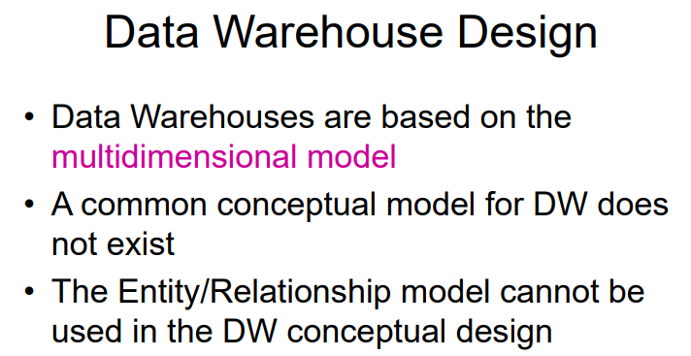

A reasonable way to present data to non-expert is to use multidimensional model. Show relevant features in a hypercube

Very common dimensions are time, …

People do not agree on the conceptual model people should use for DW, there is no agreement, we will see one common model.

Conceptual Model (dimensional fact model)

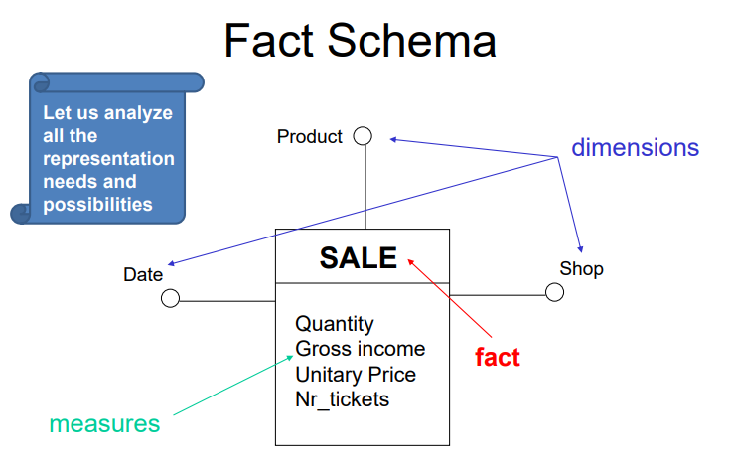

This model let you define a fact schema. A fact schema is the basic component (like an entity set). The goal of a fact schema is to describe some facts of interest of decision making. The fact of interest is made of different elements.

The name is what we are interested in analyzing (sale is just an event that can be measured in different quantities). The quantities we use to measure the actual fact are called measure.

For the sales I can have different measure such as
- number of items sold
- amount of money return
- unitary price
- number of recits produces
those are all measure of the same fact

to identify a specific event we need dimensions. Are coordinates that let you identify one primary event.

For sales we have
- date
- product
- shop
If we fix the shop, the product and the date, those three things together identify a specific sale.

The event is more abstract
The fact is a er diagram where the dimensions are the primary key (date+product+shop uniquely identify a single sale)

Quantity, gross incomes are attributes

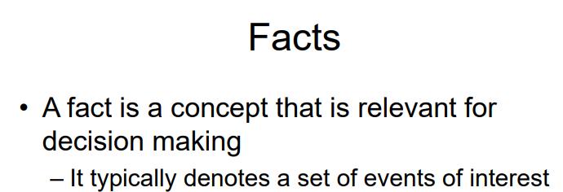

Facts are relevant to make decisions (like for CEO), a fact describes a family of events that have something in common.

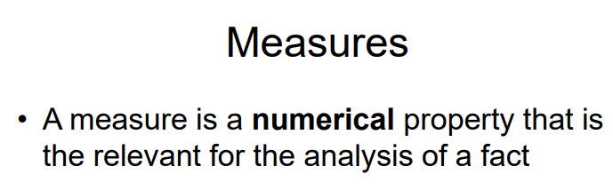

A measure is a numerical property of a fact. It is an attribute that is always numerical (we want to aggregate), it is important to somebody to make a decision.

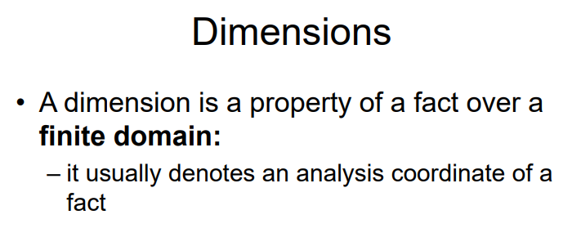
does not need to be numerical, but must take the values from a finite domain (because we want to aggregate), like a date, shop name, …

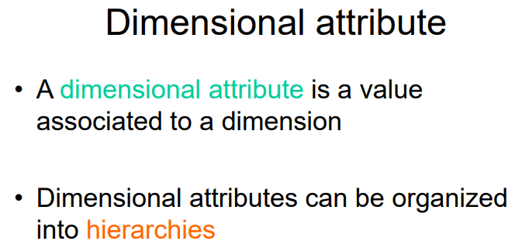

Dimensions: (the key) are also called dimensional attributes, we can start from the dimensions (first circle coming out of the box) and you can add other circles that define a less granular level of aggregation. All the other circles that go out of the dimension circle are called dimensional attributes.
- The dimension is the shop, date, product. Is the minimum level of granularity we want to define an event
- The shop can be seen as a more granular way to describe something more general (like a city). We can group many shops as in a city, so the city is a dimensional attribute (but is not a dimension)

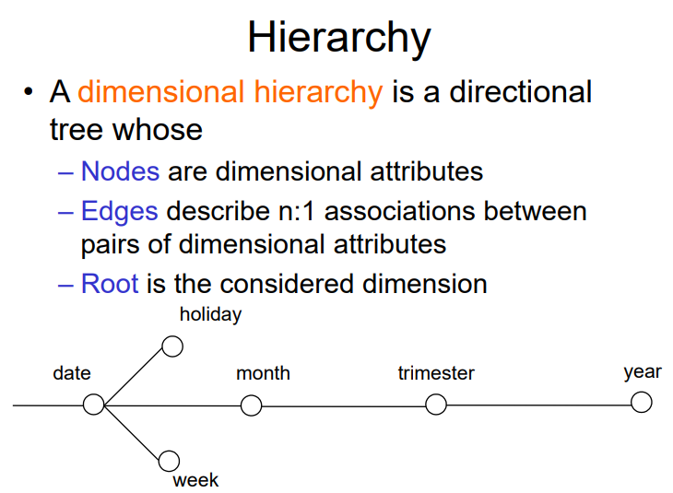

Nothing more that a tree, where the root is a dimension and the children are less granular level of the same dimension

It is a tree with a node as dimension (root), while each node is a dimensional attribute

Edges describe a many to one association from the parent to the child.

If we choose a specific date for date you can uniquely determine what should be the month, week, trimester, holiday…

In a hierarchy to make sense (to use it for aggregating the measure) there must always be a relationship from the node to the child. Given a specific value for a certain node there must be a unique way to determine the value of the child. There is a functional dependency from a node to the child.

⟹ usually for month we intend march+2002

If I have sales and from date we go to month and trimester when I want to aggregate I want to aggregate by month I just need to go through all the dates by grouping by the same month. It will be completely separated from the other groups, they will be completely separated from the other groups of the other months

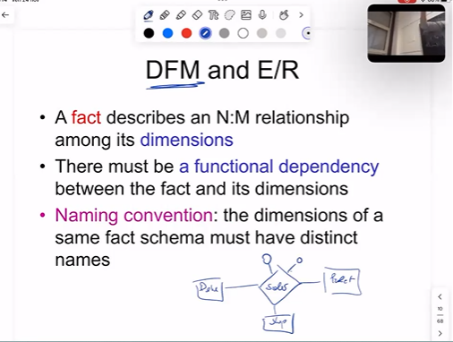

A fact is nothing else than a relationship where the name of the relationship is the fact, the dimensions are the entity set connected to it (date, product, shop) and the measures are the attributes.

Fixing the date, product and shop you have a precise sale

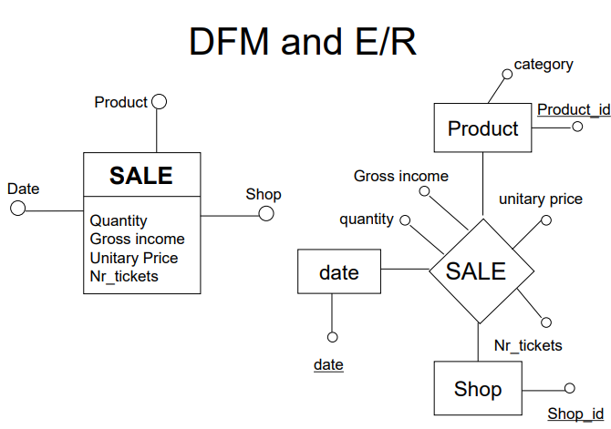

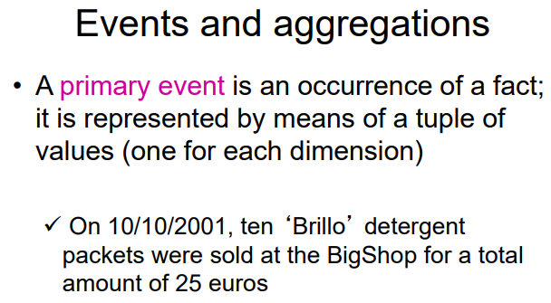
When we have a fact (like sales) it collects different events. There are two type of events:
- Primary event: specific occurrence of a certain fact. It is uniquely determined by the combination of the dimensions
  - In the example we have 3 dimensions (date, name, shop) and two measures (number of products, price).
- Secondary event
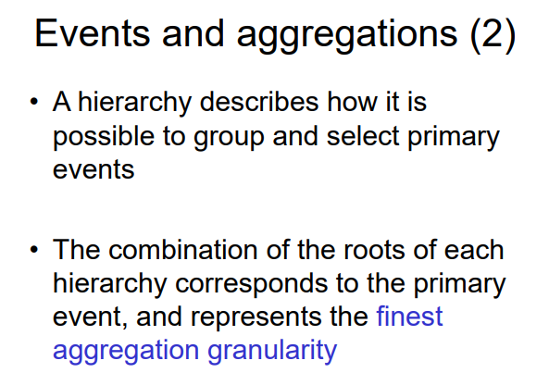

We can combine information that is not in the most granular level. If we combine the roots of each hierarchy is the primary event (because is the most granular level)

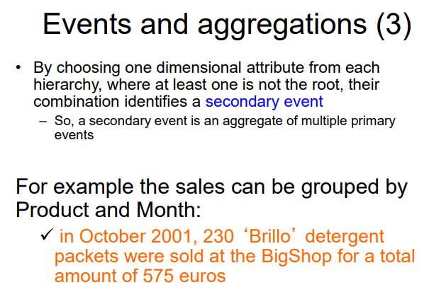

- Secondary event when at least one root is not in the most granular level. Because with three elements combined now the measure is not anymore an actual level but is the aggregation associated to the root. The measure associated is not immediate

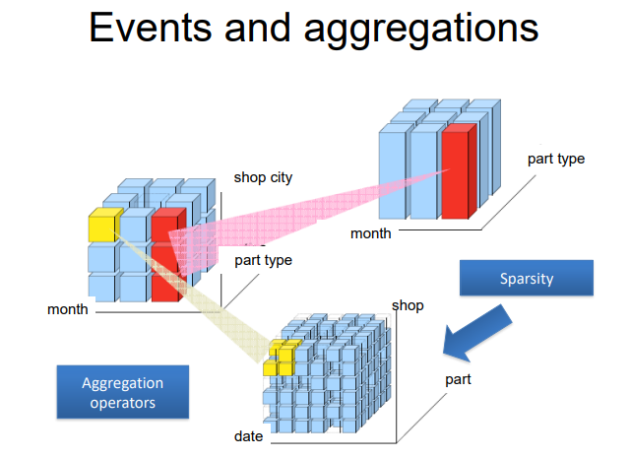
Primary event, most granular level, is the finest level.

Secondary event where we aggregate from date to month and shop to the shop city, and from the product itself to the product type (electronics, …)

Even less granular, go to the shop city to all shops, you lose one dimension. IT SHOULD BE 2D NOT 3D WITH PART TYPE AND PRODUCT TYPE

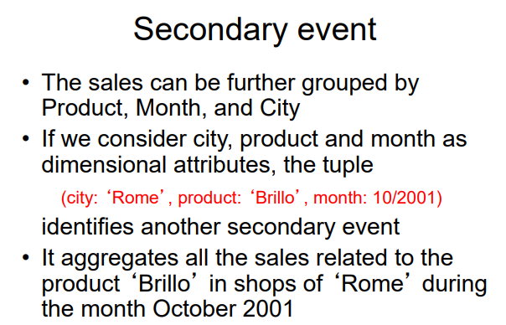

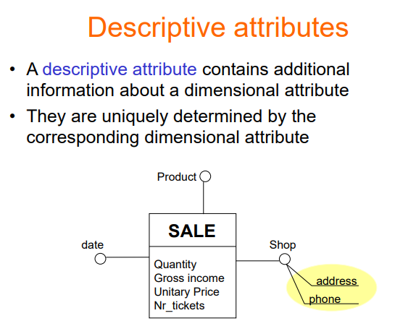
How to analyze facts of interest. There are some cases in which a dimensional attribute has some other data associated with it that is not really relevant to use for the analysis. The shop has two descriptive attributes (address and phone number).

Might not be useful at first but in the end they might become useful (like seeing where are located shop that sold 0 products).

The address and phone uniquely distinguish a shop, are alternative ways for tor the shop, we could swap shop with phone number, different name for the same thing (but might be not very important). There is a 1-to-1 correspondence

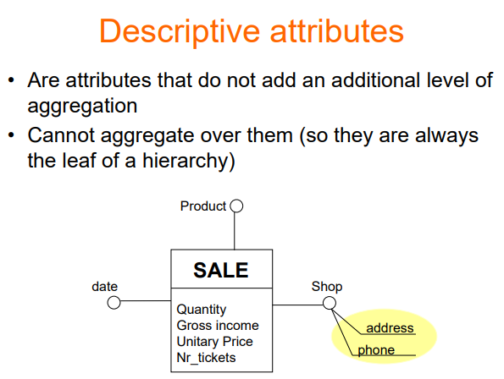
Usually can not go beyond phone number, there is nothing with less granularity

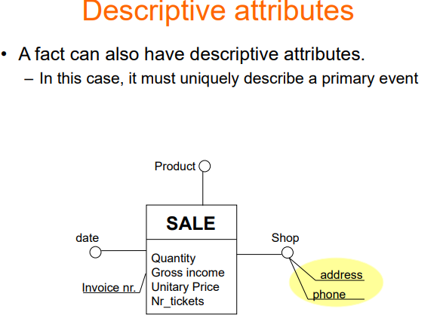
descriptive don’t help in numerical analysis, but contains additional informations

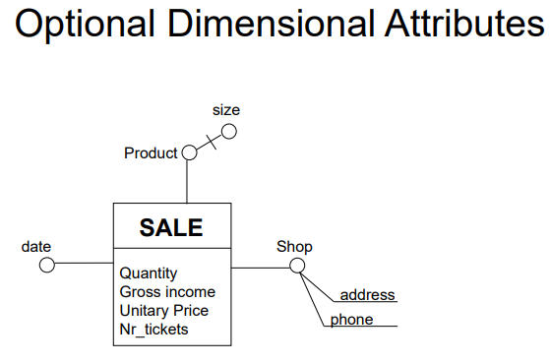
Another feature is the concept of optional dimensional attributes.

The product uniquely determines the size, this gives you hierarchies because you can group products by size. For some products there is no notion of size (like digital products, gift cards). With the | symbol we specify that the size is optional, depending on the value of the product you might have a corresponding size or a product. ⟹ when you group by size you will not consider some products because they have no size.

From size you can add shippability. If the product have a size we can traverse the hierarchy and reach shippability.

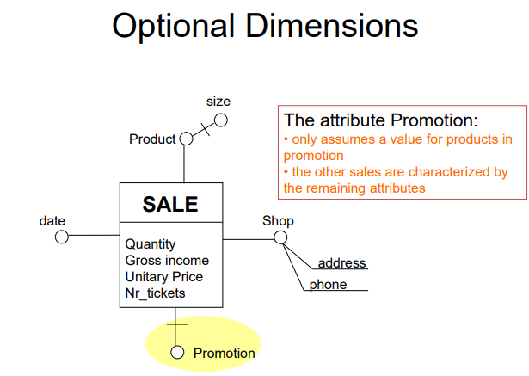
It is possible that an entire dimension is optional (like black friday, christmas promotion) some sales have no promotions, this means that some sales are uniquely identified by the date, the product and the shop.

Some other events are identity by date, product, shop and promotion

It makes the dimension disappear for some events.

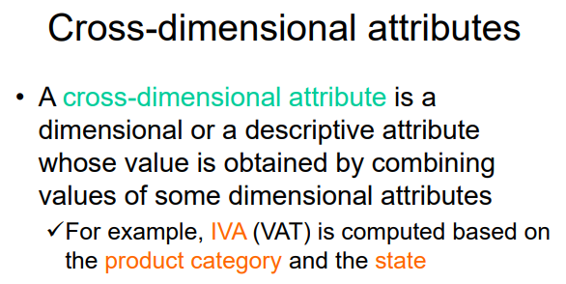

Cross-dimensional attributes is a dimensional/descriptive attribute that can not exist unless you specify two or more attributes that uniquely identify it. It is a virtual attribute constructed from other attributes.

IVA is not uniquely determined by the product itself, you need to know pasta and the country.
Also the opposite is true, if I tell you only the country you do not have enough information to tell the IVA, needs to know the product also.

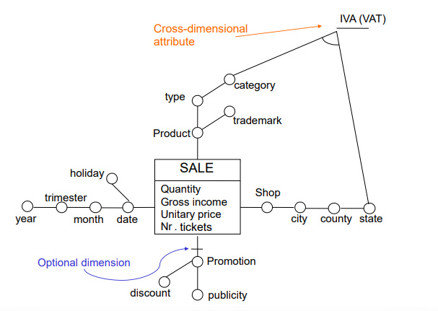
Promotion dimensional is optional but can be extended with publicity campaigns (cam marketing multiple products, or by the % of discount).

If you pick the category of product and the state it determines the cross dimensional attribute of IVA. When you aggregate over the IVA you collapse two dimensions into one.

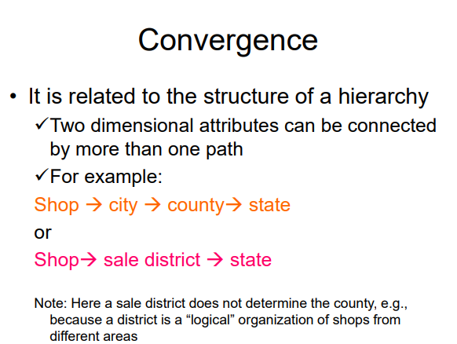

It might happen that two or more dimensional attributes converge to the same thing that is above.
In the shop dimensions there are two different paths, both reach state.

The two states are the same thing. To make explicit the convergence we write arrows

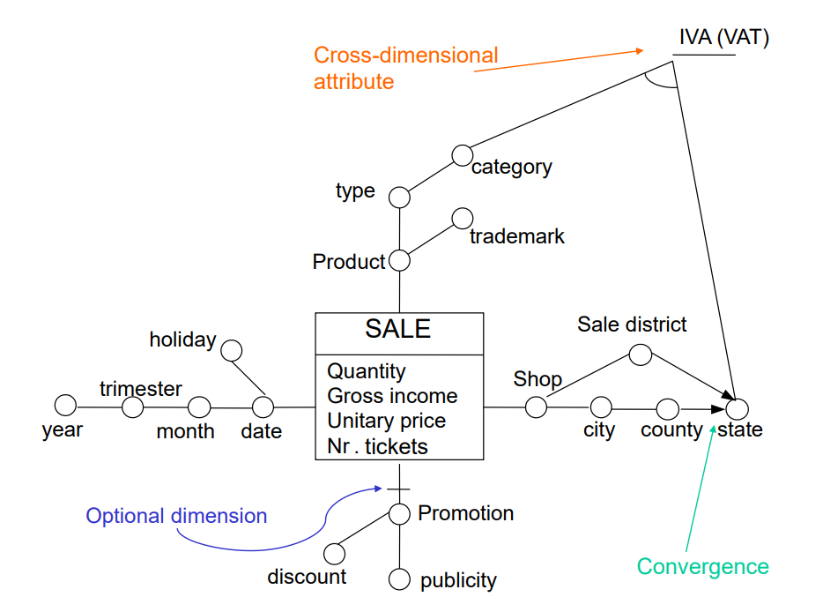

There are some cases of converges that are useless like

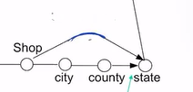it does not give other information, and needs at least one node to make sense.

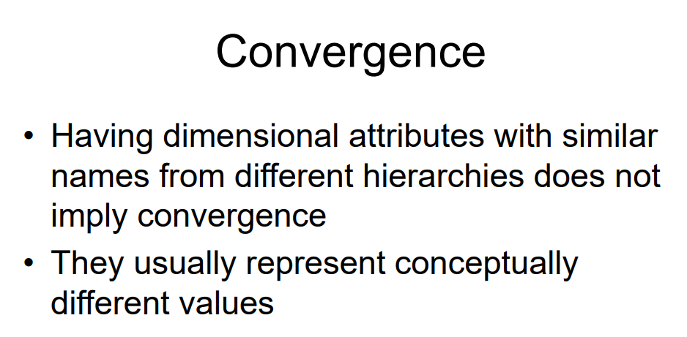

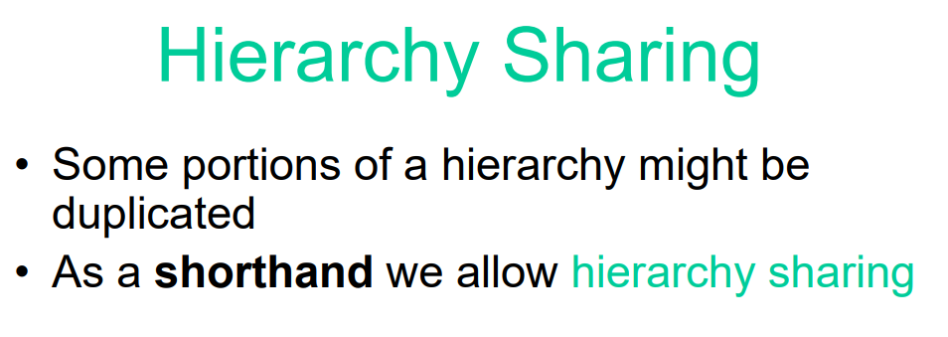

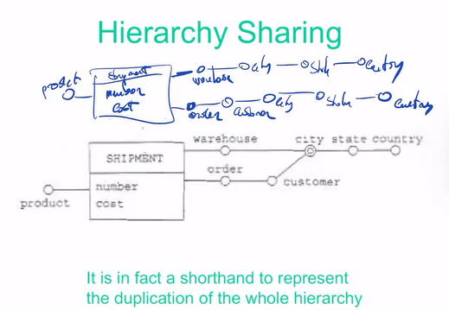
it is a short form of what I have above, the city of warehouse and order do not have anything to do.

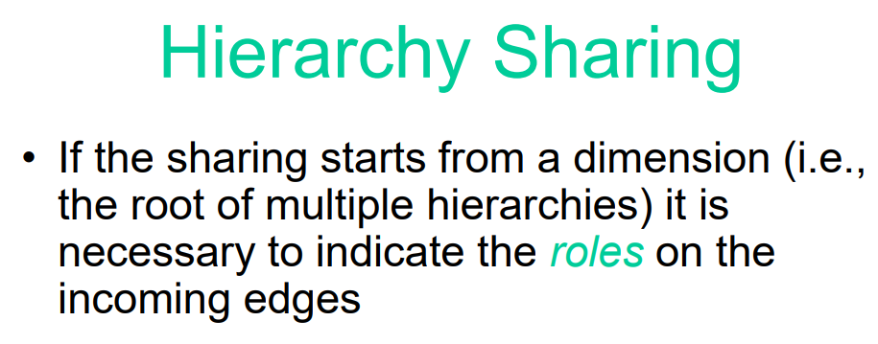

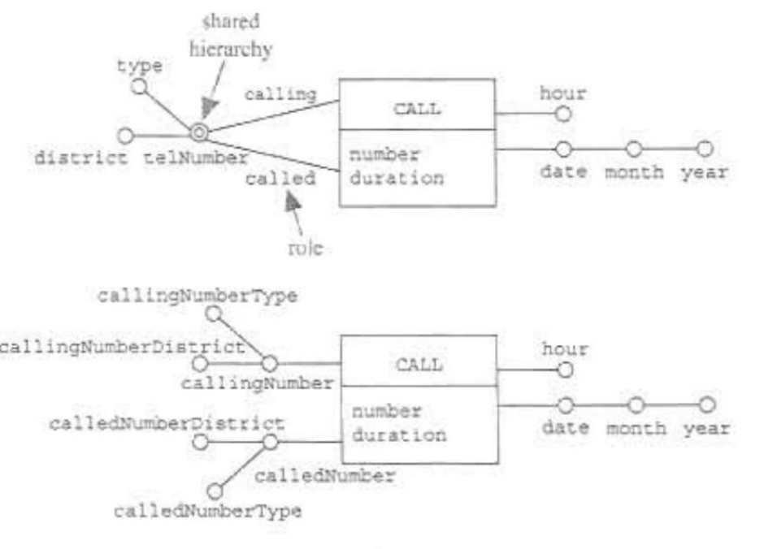
two numbers connected by the call (source and called)

Is not a convergence, they are completely independent

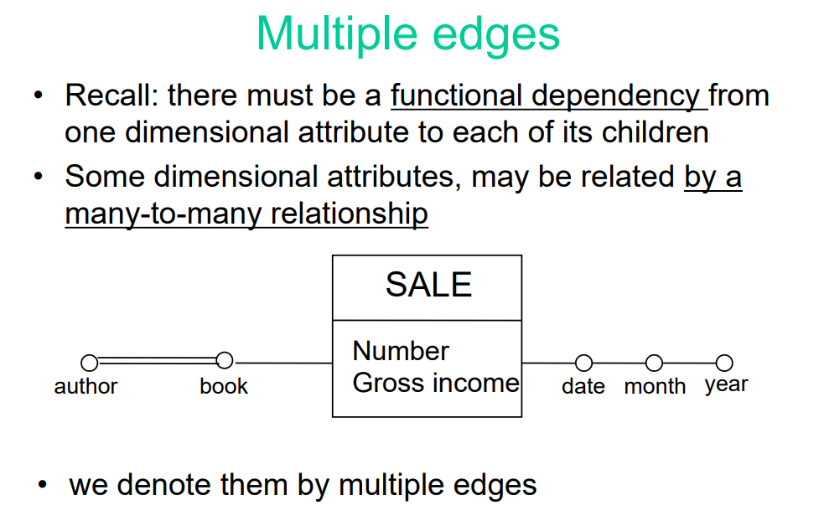

Multiple edges

The hierarchies should have functional dependency (the date uniquely determines a month, and the month uniquely determines the year). Some cases where this not happened like between author and book

A book can be written by more than one author and an author can write multiple books. Is a many-to-many relationship.

We use a double line to show a many to many relationship.

⟹ you must be very careful on aggregation.

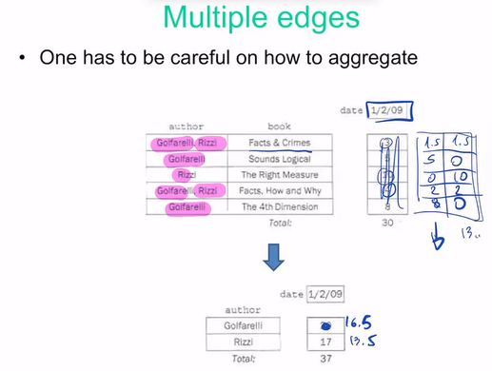

Facts and Crimes is written by Golfarelli and Rizzi and on a date it has been sold 3 times.

If I aggregate by author I get 20 for Golfarelli and 17 for Rizzi,

But the sum is wrong, because we count copies twice. You can not scale up the hierarchies as much as you want, after passing a many-to-many you are not sure that aggregate will make sense.

There are some techniques,

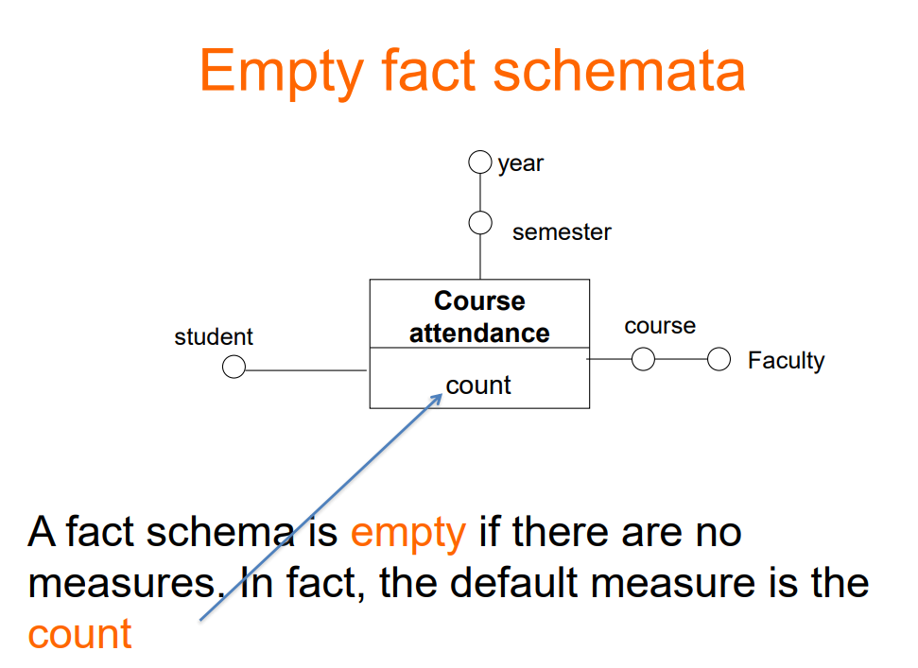

Some cases where a fact does not have measures, there is a default called count. Fixing the student, course and semesters.

There must be always a measure

